
24SDCS02 / 24SDCS02E / 24SDCS02P / 24SDCS02L – FSAD



SKILL WORKBOOK

24SDCS02 / 24SDCS02E / 24SDCS02P / 24SDCS02L FULL STACK APPLICATION DEVELOPMENT




24SDCS02 / 24SDCS02E / 24SDCS02P / 24SDCS02L – FSAD



SKILL WORKBOOK

24SDCS02 / 24SDCS02E / 24SDCS02P / 24SDCS02L - FSAD

STUDENT NAME | Ashu Kumar
STUDENT ID | 2400032678
YEAR | 2nd
SEMESTER | EVEN
SECTION
FACULTY NAME | Sridevi Sakhamuri

DEPARTMENT OF CSE, CS&IT, AI&DS
COURSE CODE: 24SDCS02 / 24SDCS02E / 24SDCS02P / 24SDCS02L FULL STACK APPLICATION DEVELOPMENT

Date of the Session: / / Time of The Session: to

#SKILL - 3 ➔ Working with HQL - Sorting, Pagination & Aggregates

Prerequisites:
- Basic knowledge of Hibernate
- Basic idea of HQL syntax

In this lab, you will extend the Hibernate module created in Skill 2 and perform advanced data retrieval using HQL, including sorting, pagination, filtering, and aggregate functions. These operations help in retrieving structured and meaningful data from the database using Hibernate.

Tasks:

- Use the Product entity created in Skill 2.
- Add 5–8 additional Product records into the database.
- Write HQL queries to retrieve all products sorted by price:
  - Ascending order
  - Descending order
- Write an HQL query to sort products by quantity (highest first).
- Implement pagination using HQL to display:
  - First 3 products
  - Next 3 products
- Write HQL queries for aggregate operations:
  - Count total number of products
  - Count products where quantity > 0
  - Count products grouped by description
  - Find minimum and maximum price
- Write an HQL query using GROUP BY to group products by description.
- Write an HQL query using WHERE to filter products within a price range.
- Write HQL queries using LIKE such as:
  - Names starting with certain letters
  - Names ending with certain letters
  - Names containing a pattern anywhere (substring)
  - Names with an exact character length
- Push the Hibernate project to GitHub.

Com.klu.app
HQLDemoApp.java

package com.klu.app; import java.util.List;
import org.hibernate.Query; import org.hibernate.Session;

import com.klu.entity.Product; import com.klu.util.HibernateUtil;

public class HQLDemoApp {

public static void main(String[] args) {

Session session = HibernateUtil.getSessionFactory().openSession();

// Sort by price ASC List<Product> list1 =
session.createQuery("FROM Product p ORDER BY p.price ASC").list(); list1.forEach(System.out::println);

// Sort by quantity DESC
session.createQuery("FROM Product p ORDER BY p.quantity DESC").list();

// Pagination
Query q = session.createQuery("FROM Product"); q.setFirstResult(0);
q.setMaxResults(3); q.list();

session.close();
System.out.println("HQL executed successfully");
}
}

InsertProducts.java

package com.klu.app;

import org.hibernate.Session; import org.hibernate.Transaction;

import com.klu.entity.Product; import com.klu.util.HibernateUtil;

public class InsertProducts {

public static void main(String[] args) {

Session session = HibernateUtil.getSessionFactory().openSession(); Transaction tx = session.beginTransaction();

session.save(new Product("Laptop", "Electronics", 55000, 5));
session.save(new Product("Mouse", "Electronics", 500, 20));
session.save(new Product("Keyboard", "Electronics", 1500, 15));
session.save(new Product("Chair", "Furniture", 3000, 10));
session.save(new Product("Table", "Furniture", 7000, 3));
session.save(new Product("Bottle", "Kitchen", 800, 25));

tx.commit(); session.close();

System.out.println("Products inserted successfully");
}
}

Com.klu.entity

Product.java

package com.klu.entity; import javax.persistence.*; @Entity
@Table(name = "product") public class Product {

@Id
@GeneratedValue(strategy = GenerationType.IDENTITY) private int id;

private String name; private String description; private double price; private int quantity;

public Product() {}

public Product(String name, String description, double price, int quantity) { this.name = name;

this.description = description; this.price = price; this.quantity = quantity;
}

public int getId() { return id; }
public String getName() { return name; }
public String getDescription() { return description; } public double getPrice() { return price; }
public int getQuantity() { return quantity; }
}

Com.klu.util HibernateUtil.java package com.klu.util;
import org.hibernate.SessionFactory; import org.hibernate.cfg.Configuration;

public class HibernateUtil {
private static SessionFactory factory; static {
try {
factory = new Configuration()
.configure("hibernate.cfg.xml")
.buildSessionFactory(); System.out.println("SessionFactory created successfully");
} catch (Exception e) { System.err.println("SessionFactory creation failed"); e.printStackTrace();
}
}

public static SessionFactory getSessionFactory() { return factory;
}
}

Src/main/java hibernate.cfg.xml
<?xml version="1.0" encoding="UTF-8"?>
<hibernate-configuration>
<session-factory>

<property name="hibernate.connection.driver_class"> com.mysql.cj.jdbc.Driver
</property>

<property name="hibernate.connection.url"> jdbc:mysql://localhost:3306/inventorydb
</property>

<property name="hibernate.connection.username">root</property>
<property name="hibernate.connection.password">Ashu@2005</property>

<property name="hibernate.dialect"> org.hibernate.dialect.MySQL8Dialect
</property>

<property name="hibernate.hbm2ddl.auto">update</property>
<property name="hibernate.show_sql">true</property>

<mapping class="com.klu.entity.Product"/>

</session-factory>
</hibernate-configuration>

Pom.xml

<project xmlns="http://maven.apache.org/POM/4.0.0" xmlns:xsi="http://www.w3.org/2001/XMLSchema-instance" xsi:schemaLocation="http://maven.apache.org/POM/4.0.0 https://maven.apache.org/xsd/maven- 4.0.0.xsd">
<modelVersion>4.0.0</modelVersion>
<groupId>com.klu</groupId>
<artifactId>Experiment-3</artifactId>

<version>0.0.1-SNAPSHOT</version>
<dependencies>
<!-- Hibernate Core -->
<dependency>
<groupId>org.hibernate</groupId>
<artifactId>hibernate-core</artifactId>
<version>5.6.15.Final</version>
</dependency>
<!-- MySQL Driver -->
<dependency>
<groupId>mysql</groupId>
<artifactId>mysql-connector-java</artifactId>
<version>8.0.33</version>
</dependency>
<!-- JPA -->
<dependency>
<groupId>javax.persistence</groupId>
<artifactId>javax.persistence-api</artifactId>
<version>2.2</version>
</dependency>
</dependencies>
</project>

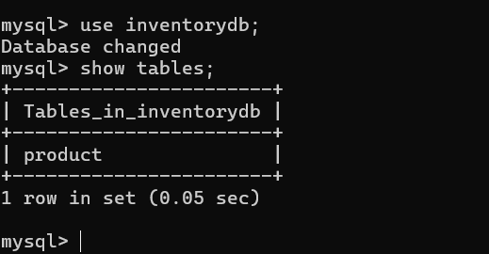

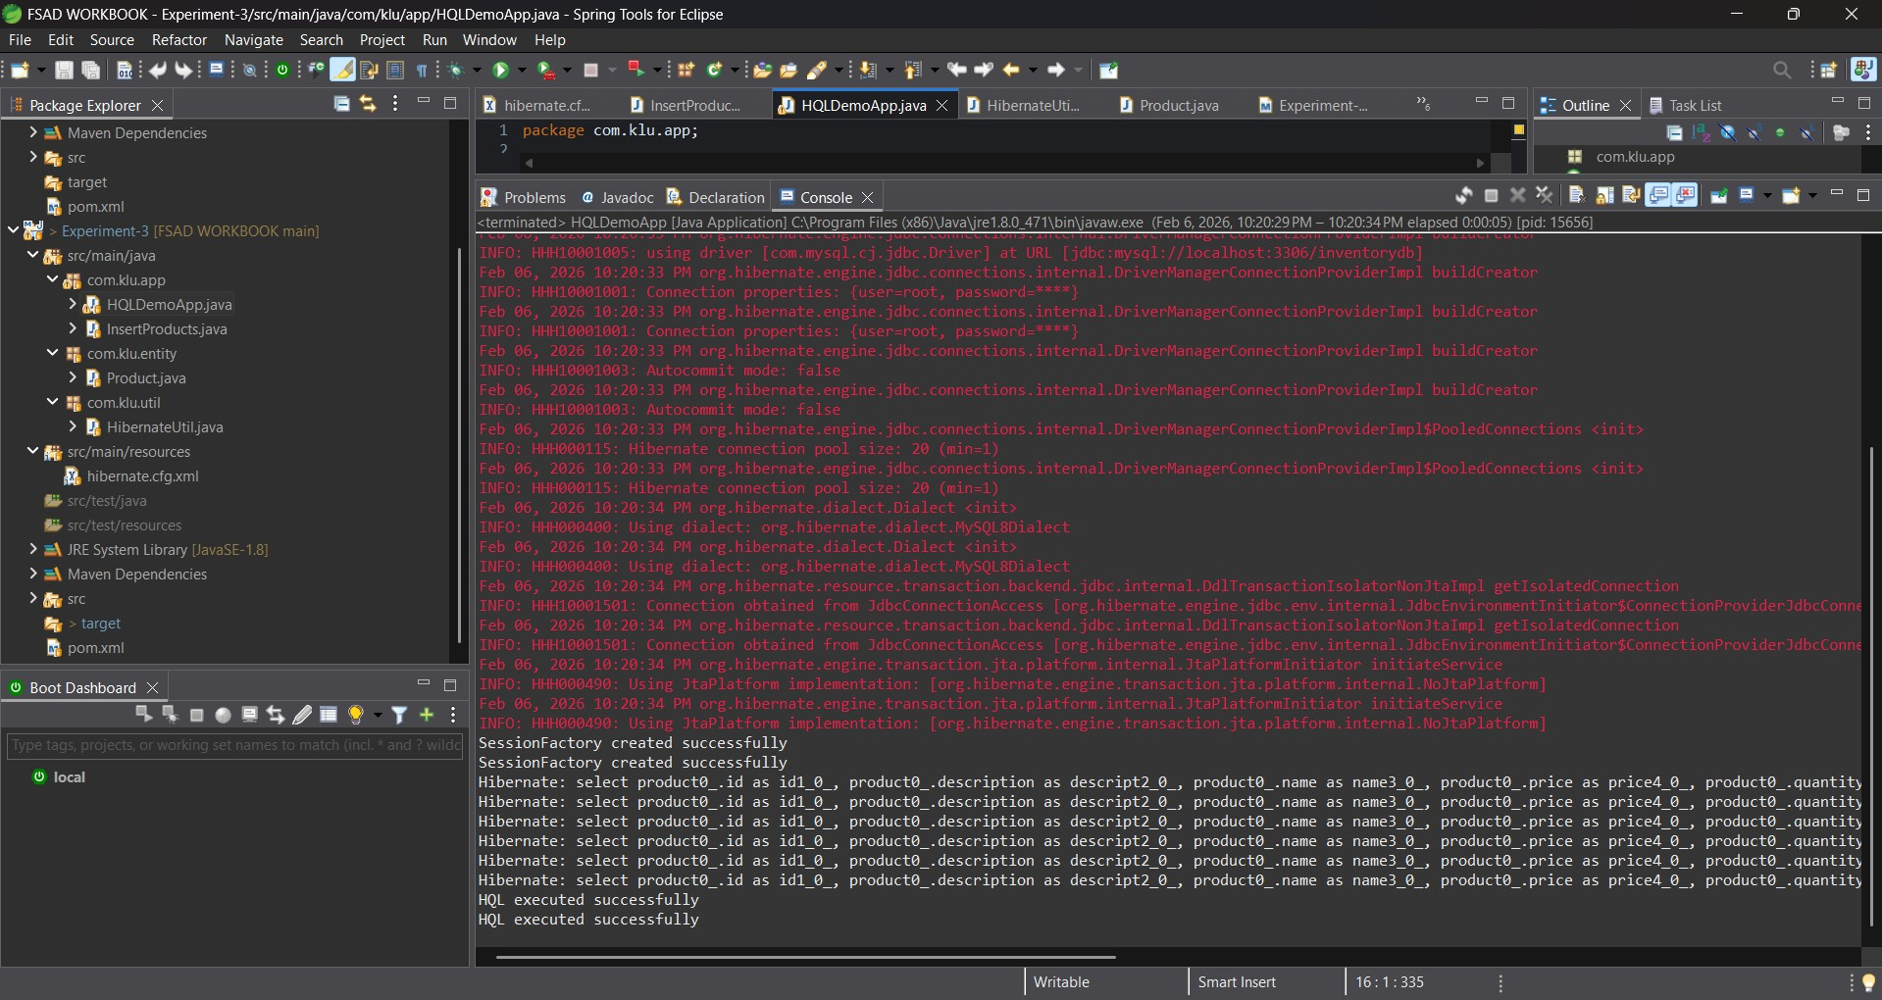

VIVA QUESTIONS:

- What is HQL and how does it differ from SQL?

HQL (Hibernate Query Language) is a query language used in Hibernate to retrieve data from the database using Java class names and properties instead of table names and column names. The main difference is that SQL works directly with database tables, while HQL works with objects and is database-independent, making it more suitable for Java applications using Hibernate.

- Why do we use sorting in HQL?

Sorting in HQL is used to arrange the retrieved data in a specific order, such as ascending or descending. It helps in organizing results based on a particular field like name, date, or salary, making the output easier to read and analyze.

- What is pagination and where is it used?

Pagination is the process of dividing large sets of data into smaller parts (pages). It is commonly used in web applications, such as search results or product listings, where displaying all records at once would be slow and difficult to manage.
Hibernate supports pagination using methods like setFirstResult() and setMaxResults().

- Name any three aggregate functions supported in HQL.

Three aggregate functions supported in HQL are COUNT(), SUM(), and AVG(). These functions are used to perform calculations on groups of data.

- What is the difference between HQL and HCQL (Hibernate Criteria Query Language)?

HQL is a string-based query language where queries are written manually as text, similar to SQL. HCQL (Criteria Query Language) is a programmatic way of creating queries using Java objects and methods instead of writing query strings.
HQL is easier for simple queries, while HCQL is useful for dynamic queries where conditions change at runtime.

(For Evaluator’s use only)

 | Comment of the Evaluator (if Any) |  | Evaluator’s Observation  Marks Secured: out of  EMP ID & Full Name of the Evaluator:  Signature of the Evaluator Date of Evaluation:

24SDCS02 / 24SDCS02E / 24SDCS02P / 24SDCS02L – FSAD WORKBOOK

